**Project Design Phase-II Technology Stack (Architecture & Stack)**

|  |  |
| --- | --- |
| Date | 15 October 2022 |
| Team ID | PNT2022TMID00114 |
| Project Name | Project – Smart Farmer- IoT Enabled smart farming Application |
| Maximum Marks | 4 Marks |

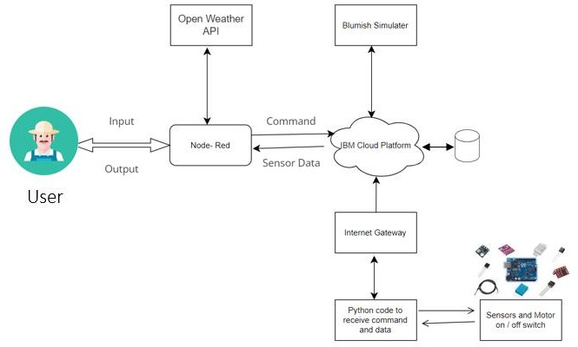

1. The different soil parameters temperature, soil moistures and then humidity are sensed using different sensors and obtained value is stored in the IBM B2 cloud.
2. Arduino UNO is used as a processing Unit that process the data obtained from the sensors and whether data from the weather API.
3. NODE-RED is used as a programming tool to write the hardware, software and APIs. The MQTT protocol is followed for the communication.
4. All the collected data are provided to the user through a mobile application that was developed using the MIT app inventor. The user could make a decision through an app, weather to water the field or not depending upon the sensor values. By using the app they can remotely operate the motor switch.

**Table-1 : Components & Technologies:**

|  |  |  |
| --- | --- | --- |
| Component | Description | Technology |
| 1. User Interface | How user interacts with  application e.g. Web | MIT App Inventor |
| 2. Application Logic-1 | Logic for a process in the  application | Python |
| 3. Application Logic-2 | Logic for a process in the  application | IBM Watson IOT service |
| 4. Application Logic-3 | Logic for a process in the  application | IBM Watson Assistant |
| 5. Database | Data Type, Configurations  etc. | MySQL, NoSQL, etc. |
| 6. Cloud Database | Database Service on Cloud | IBM Cloud |
| 7. File Storage | File storage requirements | IBM Block Storage or Other  Storage |
| 8. External API-1 | Purpose of External API  used in the application | Open Weather API |
| 9. Infrastructure (Server / Cloud) | Application Deployment on Local System / Cloud  Local Server Configuration:  Cloud Server Configuration: | Local, Cloud Foundry. |

**Table-2: Application Characteristics:**

|  |  |  |  |
| --- | --- | --- | --- |
| **S.No** | **Characteristics** | **Description** | **Technology** |
| 1. | Open-Source Frameworks | List the open-source frameworks used | Technology of Opensource  framework |
| 2. | Security Implementations | Sensitive and private data must be protected from their production until the decision-making and  storage stages. | Node-Red, Open weather App API, MIT App Inventor |
| 3. | Scalable Architecture | scalability is a major concern for IoT platforms. It has been shown that different architectural choices of IoT platforms affect system scalability and that automatic real time decision-making is feasible in an environment composed of dozens of  thousand. | Technology used |

**References:**

<https://c4model.com/>

<https://developer.ibm.com/patterns/online-order-processing-system-during-pandemic/>

<https://www.ibm.com/cloud/architecture/>